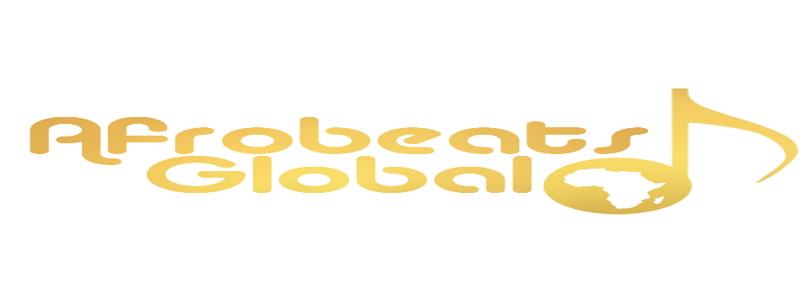

**VOICE OF AFROBEATS 2024 VOTES**

|  |  |
| --- | --- |
| Artist Names | Votes |
| TheSixthSurprise | 1282 |
| Kelschi Og | 1029 |
| CLUTOVERSE | 875 |
| Tife | 184 |
| Arewa Xlaz | 100 |
| Dniell | 92 |
| Big Berry | 77 |
| Diceydave | 70 |
| Omasong | 40 |
| Babatobby | 32 |
| Hezhard | 30 |
| MEXIE | 19 |
| DREAMER | 25 |
| Empro | 14 |
| OLAZZYBMN | 5 |
| Boy_Rhydim |  |
| LythBoy |  |
| Dorsche |  |
| CLUTOViLL |  |
| LULU |  |
| Riddim |  |
| 3eazy |  |
|  |  |

The prizes for the VOA Top 3 are as follows **(cash value: #300,000)**

**Winner**:

1. #150,000

2. Complete studio session which includes beat, recording session, with mix and mastering.

3. Artist profile on our blog

4. Exclusive interview session to be uploaded on our socials

**1st runner up:**

1. #100,000

2. Artist profile on our blog

3. Exclusive interview session to be uploaded on our socials

**2nd runner up:**

1. #50,000

2. Artist profile on our blog